Name
10th Magnitude [Company address]
Workload Discovery
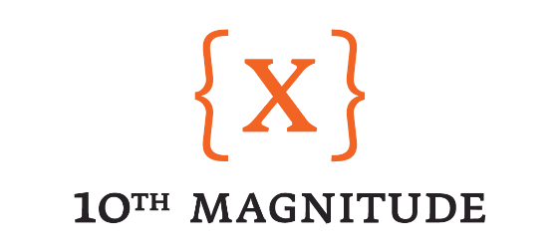

Workload Discovery - Overview

Description

The goal of Workload discovery is to understand how workloads are built, maintained, and managed at your organization. During this session we would like to do a deep dive on your current build standards and practices.

Approach

During this design session we are going to be working towards what the process around workload deployment is. We will be focused on understanding handoffs, team responsibilities, and procedures as it pertains to workload deployment.

Goal

The goal of this session is to have thorough understanding of how systems get installed and what the core standards are that need to be delivered as part of the build process. This should include any tools that are leveraged for compliance, monitoring, or security.
This information will be used to create the design for the deployment heading into the next phase of the project.

Workload Discovery – Questions

The following questions will guide us in understanding the workload deployment process. Feel free to answer these questions ahead of the Cloud Design Sessions if possible. As part of the design sessions, we will ensure that these questions are answered in order to progress to the design and build phases of the project.

- What Operating Systems do you support today?
  - Windows 2003, Windows 2008, Windows 2016, Windows 2019, Cent OS 5 - 7.7, Ubuntu 14.04 LTS, Ubuntu 18.04 LTS, Red Hat Enterprise 4 - 7, Suse Enterprise 11
- What are your system build practices today?
  - Current build off VMware template, customize OS, deploy applications.
  - Future working with newly created DevOps group on automation of all processes of build
- What primary database platforms and versions do you support today?
  - Microsoft SQL 2008-2017
  - MySQL
- What agents, tools, utilities, and automation activities do you support on your systems today?
  - Duo MFA
  - SentinelOne (AV engine)
  - AD GPO
- What are your system security requirements? Encryption, tooling, monitoring/audits, server hardening, SIEM software
  - SIEM LogRhythm
  - SolarWinds for peformance monitoring
  - AD Audit Plus for monitoring/audits
- Do you have any regulatory compliance requirements that must be met? (example: data retention periods, GDPR)
  - SOX
  - HIPPA
- What are your critical business workloads and how is the associated data structured?
  - Drilling Support (
    - district warehousing
    - COE
    - Industrial Control System
    - Kronos
    - Vantage
    - Rig Asset Management, EHS Insight, Viper +
    - Satellite control
  - Payroll
    - Workday
    - Payroll translator
    - Crew overages
  - Supply Chain
    - Oracle EBS
    - Vantage
  - Billing
    - Oracle EBS
  - Accounts Receivable
    - Oracle EBS
    - Viper +
    - Vantage
  - Finance
    - Oracle EBS
  - IT
    - Active Directory/DNS
    - VPN
    - Citrix
    - Email
    - Voicemail
    - ServiceNow
    - Microsoft Teams
    - Office 365
    - SharePoint
    - FileShare
    - Internet connectivity for district offices
  - HPTech
    - BGS
    - Autoslide
    - Saphirra

- What is your current BCDR strategy for your various workloads?
  - DRBCP project currently active developing policies and plans for BCDR.
- How are these workloads differentiated between Production, QA, Dev/test etc.?
  - HPINC
    - Not all environments have QA/UAT environment
    - Dev has mulitple workloads
    - Not all environment have Dev

